**C++ Programming Lab**

Assignment: 1



Department of computer Science and engineering

**Submitted by: Submitted To:**

Name : Saurav Shrivastav Mr.Hemant petwal

Roll no: 101903467

Group: I8

**Question 1:** Write a program (WAP) to display &quot;Hello World&quot; on console display.

**Code:**

#include <iostream>

using namespace std;

int main(){

cout << "Hello World!";

return 0;

}

**Output:**

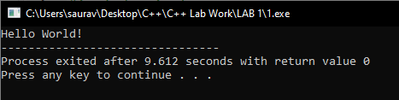

**Question 2:** WAP to implement the following control characters:

(a) ‘\n’ is for new line, or you can use endl – cout&lt;&lt;endl&lt;&lt;“message”;

(b) ‘\t’ is for tab

(c) ‘\a’ is an alarm sound

(d) ‘\r’ is carriage return to go to the beginning of the current line

**Code:**

#include <iostream>

using namespace std ;

int main(){

cout << "Access specifiers in C++:\n \t1. Public \n \t2. Private \n \t3.Protected";

cout<<"\nCOMPUTER\a SCIENCE \n";

cout<<"COMPUTER\rSCIENCE";

return 0;

}

**Output:**

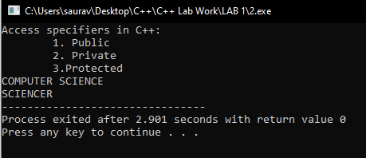

**Question 3:** Implement namespace in a program to illustrate the use of same name variables and

functions in different sections/libraries of the code.

**Code:**

#include <iostream>

using namespace std;

namespace ns1 {

int value() {

return 5;

}

}

namespace ns2 {

int x=10;

double value() {

return 4.99;

}

}

int main() {

cout << ns1::value() << endl;

cout << ns2::value() << endl;

cout<< ns2::x<<endl;

}

**Output:**

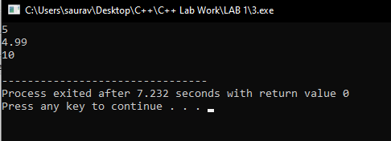

**Question 4:** Write a program to define a structure Student with two three variables (a) Name (b)

Roll (c) Marks and two functions (1) setStudentData(…) (2) getStudentData(…). Use

loops to input and output 3 student object entries.

**Code:**

#include <iostream>

using namespace std;

struct Student {

char Name[3][20];

int roll[3], marks[3];

int setStudentData(int i){

cout << "Enter the Name: ";

cin >> Name[i] ;

cout << "Enter the ROLL NO.: ";

cin >> roll[i];

cout << "Enter the marks: ";

cin >> marks[i];

}

int getStudentData(int i){

cout << "\n\nName: " << Name[i] << "\tMarks: " << marks[i] << "\tRoll No.: " << roll[i] ;

}

};

int main(){

Student S1;

int i;

for(i=0 ; i<3 ; i++){

S1.setStudentData(i);

}

for(i=0 ; i<3 ; i++){

S1.getStudentData(i);

}

}

**Output:**

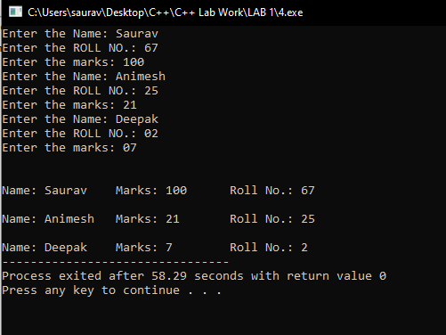

**Question 5:** In the previous program make the variables private, and data to be public.

**Code:**

#include <iostream>

using namespace std;

struct Student {

private:

char Name[3][20];

int roll[3], marks[3];

public:

int setStudentData(int i){

cout << "Enter the Name: ";

cin >> Name[i] ;

cout << "Enter the ROLL NO.: ";

cin >> roll[i];

cout << "Enter the marks: ";

cin >> marks[i];

}

int getStudentData(int i){

cout << "\n\nName: " << Name[i] << "\tMarks: " << marks[i] << "\tRoll No.: " << roll[i] ;

}

};

int main(){

Student S1;

int i;

for(i=0 ; i<3 ; i++){

S1.setStudentData(i);

}

for(i=0 ; i<3 ; i++){

S1.getStudentData(i);

}

}

**Output:**

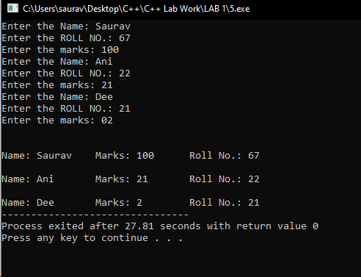

**Question 6:** Convert program #4 from struct to class.

**Code:**

#include <iostream>

using namespace std;

class Student {

public:

char Name[3][20];

int roll[3], marks[3];

int setStudentData(int i){

cout << "Enter the Name: ";

cin >> Name[i] ;

cout << "Enter the ROLL NO.: ";

cin >> roll[i];

cout << "Enter the marks: ";

cin >> marks[i];

}

int getStudentData(int i){

cout << "\n\nName: " << Name[i] << "\tMarks: " << marks[i] << "\tRoll No.: " << roll[i] ;

}

};

int main(){

Student S1;

int i;

for(i=0 ; i<3 ; i++){

S1.setStudentData(i);

}

for(i=0 ; i<3 ; i++){

S1.getStudentData(i);

}

}

**Output:**

